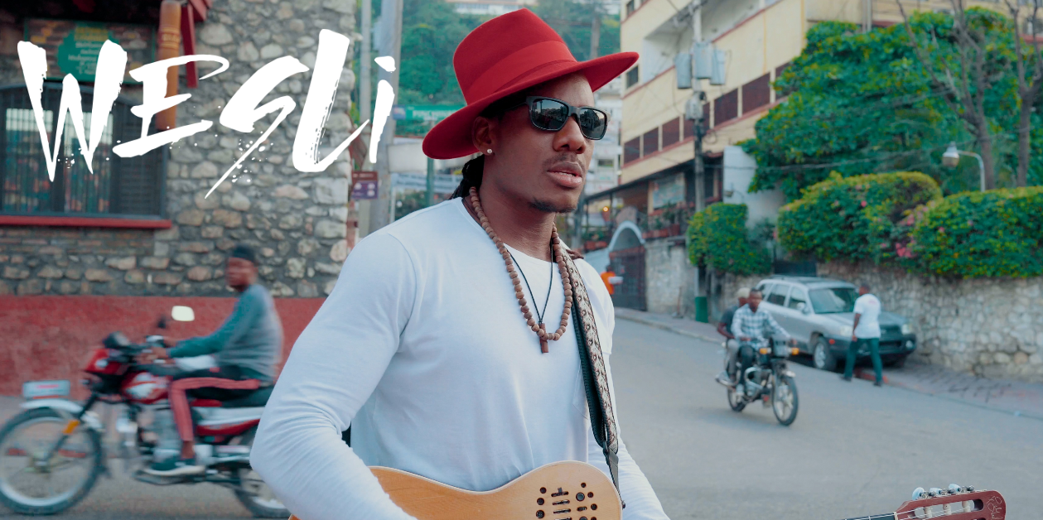

WESLI’S MUSICAL JOURNEY HAS GONE FROM STRINGING UP AN OIL CAN WITH NYLON FISHING STRING TO WINNING A JUNO FOR WORLD MUSIC ALBUM OF THE YEAR.

Born Wesley Louissaint in Port-au-Prince, Haiti, he has grown into his role as a prolific songwriter, guitarist, and producer. Uniting a large cross-section of Montreal talent, his music links Haitian vodou and rara with Twoubadou roots, Afrobeat and reggae – guest spots on his albums have included the likes of Tiken Jah Fakoly, AfrotroniX, Mes Aïeux, Paul Cargnello and Radio Radio.

Since being crowned the Revelation Radio-Canada for 2009–2010, Wesli has gone on to win the Babel Med Music Prize (2010), SOCAN’s Hagood Hardy (Composing) Award (2016), an award from the Académie Charles CROS (2019) for Diaspora representation, a JUNO for World Music (2019), a Félix for Album of the Year in World Music (2019), and a CFMA for World Solo Artist of the Year (2020). He has toured across North America, Haiti, Colombia, Brazil, and Europe, and participated in WOMEX, Mundial Montréal and Cape Verde’s Atlantic Music Expo.

Wesli’s unstoppable creativity led to two album releases in 2015: the star-studded Immigrand alongside the more traditional Ayiti Étoile Nouvelle. Rapadou Kréyol (2018) was followed by his 7th album, "Tradisyon'', released internationally on Oct 21, 2022, in partnership with the American label Cumbancha. Tradisyon Volume 2 will be released in 2024.
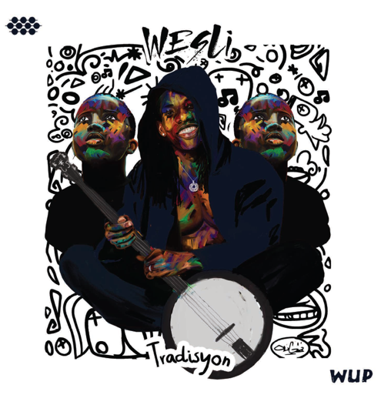
TRADISYON

Tradisyon is the first of a two-part project that retells the story of Haiti’s past and imagines its future. “You have to know where you’re from to know where you’re going,” says Wesli, the acclaimed Montreal-based winner of the prestigious 2019 JUNO Award.

Overflowing with 19 songs, Tradisyon explores traditional chants from the voodoo religion, explosive carnival rara rhythms and lilting, folksy twoubadou songs.

PRESS

“I’d never seen delivered music new to my ears but instantly inviting. Complex but never busy, they came across as an extremely seasoned unit dedicated to escaping gravity and inviting us along for the ride. “ - American Blues Scene

“Tradisyon is the first of a diptych of albums engaging directly with Haitian music: this one looks back, and the second instalment will look forward and more widely, with a syncretic blend of electronic music, Afrobeat, soul, funk, hip-hop and more.” ★★★★ - Financial Times, UK

“Wesli weaves contemporary messages into traditional forms, keeping a wide range of roots percussion at the heart of open‐eared arrangements.” -American Songwriter, USA

VIDEOS

- Blackman Samba - Official 4k Video
THE BAND
Wesli – Lead vocal, percussions, guitar
Cindy Belotte – Back vocal, danse
André Desilets – Saxophone
Martine Labbé – Trumpet
David Mobio – Keyboard
Watson Joseph – Bass
Michel Medrano Brindis – Drums

- Le Soleil Descend – Official Video
- Lolé Lolé live session video
- Live video 2022

PRIX

2024 Male Solo Artist of the Year
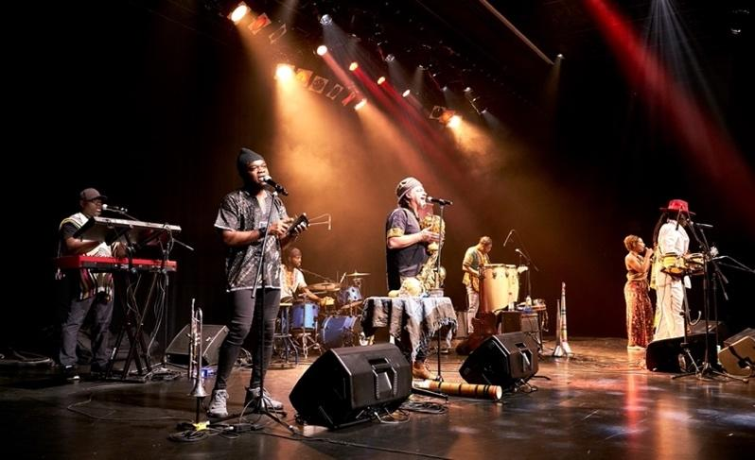
Prestigious Haitian Music Awards, MIAMI
2023 JUNO AWARD NOMINATION
2023 Prix FÉLIX NOMINATION
2023 CFMA/PMFC Nomination
2020 Canadian Folk Music Award
Artist of the year – World Music – Solo
2020 Independent Music Awards
World Trad Song of the Year - Lole Lole Remix
2019 Adisq – World Music Album of the Year
2019 Juno Award – World Music
2019 Prix Coup de Coeur Académie Charles CROS
2017 Dynasty World Music Award
2016 Socan Music Award Hagood Hardy
2011 Galaxy Rising Star London
2010 Babel Med Music Award, France
2010 Révélation Radio-Canada

CONTACT FOR BOOKINGS & MANAGEMENT

Heidi Fleming heidi@famgroup.ca +1 514-844-7393 Famgroup.ca

*For other contacts (Bookings USA, Canada, label, etc) visit
www.wesliband.com | Facebook| Instagram

